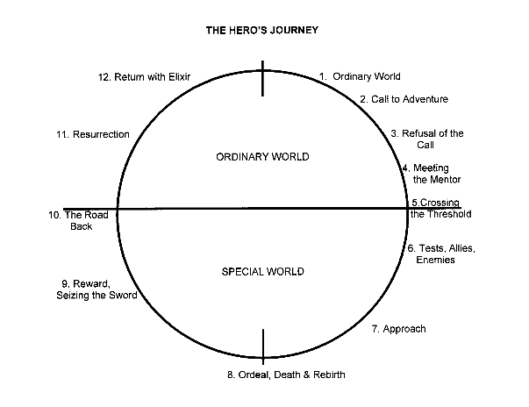

7. When Uncle Monty dies they go to their next of kin Aunt Josephine.

8. Aunt Josephine gets killed and it seems like he has won they don’t know what to do then they realize her so called suicide note was actually a code and they find her at curdle cove.

12. Return- They have found that there are bad people in the world and to trust no one. That there is always a way as Violet always quotes that they do have each other’s talent. Klaus becomes inventive to fix the marriage problem.

11. Resurrection: That Count Olaf is back and wants to get married to violet and steal all of their fortune through marriage. So they set fire to the paper with clause as he finds the magnifier that set fire to the houses in the top of Olaf’s tower.

10: ………… There is no road back.

9. Reward – They learn never to give up hope that there is always something. They have more knowledge. About life and how to deal with Count Olaf.

5. Meeting with the mentor: Uncle Monty guides them happily on their journey about thing and helps them learn about people and lots about their parents and past.

6. Tests allies and enemy’s: Count Olaf comes as an imposter to kill Uncle Monty and get the children back so that he can get the fortune but the viper helps them by being nice to Sunny proving Count Olaf wrong and the government can see that he was the imposter

Who are their allies and how do they help?

3 Refusal of the call Klaus Sunny and Violet are told to do a number of horrible chores. Until one day Klaus gets hit because he doesn’t agree with count Olaf and then he tries to escape and violet has to talk him out if it

4 Threshold: Count Olaf puts them in front of a train and tries to kill them but Mr Poe takes them away from Olaf. Then they get taken to their uncle Monty’s

1. Call – Mr Poe the social worker sends them to their so called closest relative Count Olaf. Who they think is weird and creepy.
2. The ordinary: the children have just lost their parents to a terrible fire, they have lost their home and all of their belongings